Effect of dental status on social participation among older adults: using a

[Targeted Maximum Likelihood Estimator](https://academic.oup.com/aje/article/185/1/65/2662306)

### Introduction

The term "social participation" refers to an individual's involvement in activities that allow them to interact with others in society or the community [@levasseur2010]. Social participation among older adults is regarded as an essential component of healthy aging because it has numerous positive effects on both individuals and society [@Golinowska2016]. Previous studies have linked higher levels of social participation to survival, better health-related quality of life, well-being, and functioning of older adults [@Wanchai2018; @dahan2008]. It is also possible to execute community-level health promotion and prevention activities such as physical activity and smoking and alcohol habit interventions through social engagement [@Saito2019]. However, a variety of socio-demographic and health-related factors have been found to influence the level of social participation among older adults [@Cornwell2009].

Teeth and oral health play an important role in speaking, smiling, and facial expressions, which are essential for positive social interactions. Tooth loss is common in older adults as a result of a life-long accumulation of chronic dental conditions such as dental caries and periodontal diseases [@Griffin2012]. Previous studies have found an association between social participation and dental status in older adults. [@Takeuchi2013]. However, no studies have been conducted to examine how changes in dental status affect social participation. This could be primarily due to the inability to conduct randomised experiments to manipulate individuals' dental status in community settings.

Longitudinal modified treatment policies (LMTPs) are a recently developed non-parametric alternative that can yield the effects of hypothetical interventions such as reducing or increasing exposure by a set amount [@díaz2021]. This framework can be adapted to seek answer to questions such as, "What would have happened to the prevalence of social participation if everyone in the study population increased or decreased their dental status by a certain amount?", "What if everyone who is edentulous became dentate?", and "What if everyone lost their teeth?", utilising observational data. Furthermore, LMTPs can be estimated using sophisticated doubly-robust estimators, such as the targeted maximum likelihood estimator (TMLE), which allows for the use of flexible machine learning predictions [@Laan2011].

This study presents an analysis that estimates the effect of dental status on social participation while taking the time-varying nature of variables into account. We used LMTPs to dynamically change the level of exposure (number of remaining natural teeth) in order to investigate its effect on social participation in community-dwelling older adults in Japan within 6 years of follow-up. A higher number of teeth would, presumably, have a positive impact on social participation. Hence, we hypothesized that as the number of teeth increases, social participation improves, and as the number of teeth decreases, social participation declines among older adults.

### Methods

#### Data

We used data from the Japan Gerontological Evaluation Study (JAGES) [@Kondo2018]. JAGES is an on-going nationwide cohort study for community-dwelling independent older adults in Japan aged 65 years or over. In this study, data from the 2010 survey as the baseline and two subsequent follow-up surveys (2013 and 2016) were used. We identified 52,053 functionally independent individuals at the baseline survey. Out of them 24,872 individuals had responded to all three waves of JAGES (i.e. 2010, 2013, and 2016). During the 6 years of follow-up 5,561 had died, 7,149 were ineligible as they became functionally dependent, and 14,471 were lost to follow-up due to other reasons. A comparison of baseline characteristics by participants follow-up status (i.e. died/ became ineligible/ lost to follow-up/ remained) is reported in supplementary table xx.

After excluding participants with missing information for number of teeth in 2010 (n= 669) and social participation in 2016 (n=1,752) a total of 22,451 participants were included in the analyses. The selection of the analytical sample is shown in Figure 1. Baseline characteristics of the participants who were excluded due to missing information are compared in supplementary table xx.

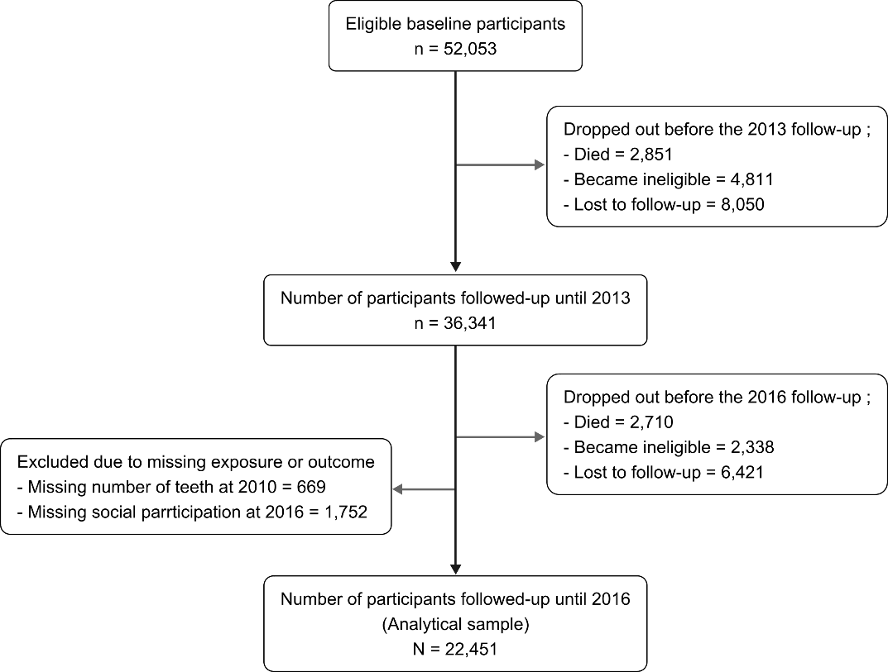

#### Outcome variable

Social participation in 2016 was the outcome in this study. JAGES recorded the frequency of participation (“nearly every day,” “twice or thrice a week,” “once a week,” “once or twice a month,” “a few times/year,” “never”) for various social activities. We assessed the frequency of participation in any of the following activities: hobby groups, sports clubs, senior citizens' clubs, residence groups, or volunteer groups. Participation in any of the aforementioned activities once a month or more frequently (vs. less frequently or never) was defined as indicative of social participation (1 = participation, 0 = non-participation).

#### Exposure

The number of remaining natural teeth at the time of the surveys in 2010 and 2013 was used as a time-varying exposure in our analyses. The self-reported number of teeth was recorded using the response to the question, "How many natural teeth do you currently have?" (Instructions: capped/crowned teeth should be counted as "natural teeth"). The responses of participants were recorded in four categories (i.e., 20 teeth/ 10-19 teeth/ 1-9 teeth/ no teeth).

#### Covariates

We controlled our analyses for both time-invariant and time-variant covariates because the number of teeth was assessed as a time-varying exposure. Age (range 65-99 years), sex (male/female) and social participation in 2010 (baseline outcome) were adjusted for as time-invariant covariates. As time-variant covariates, equalised annual household income (million yen), denture use (yes/no), instrumental activities of daily living (IADL) score (0-13), and marital status (married/ single, widowed or divorced) were used (measured in 2010 and 2013).

*Statistical analysis*

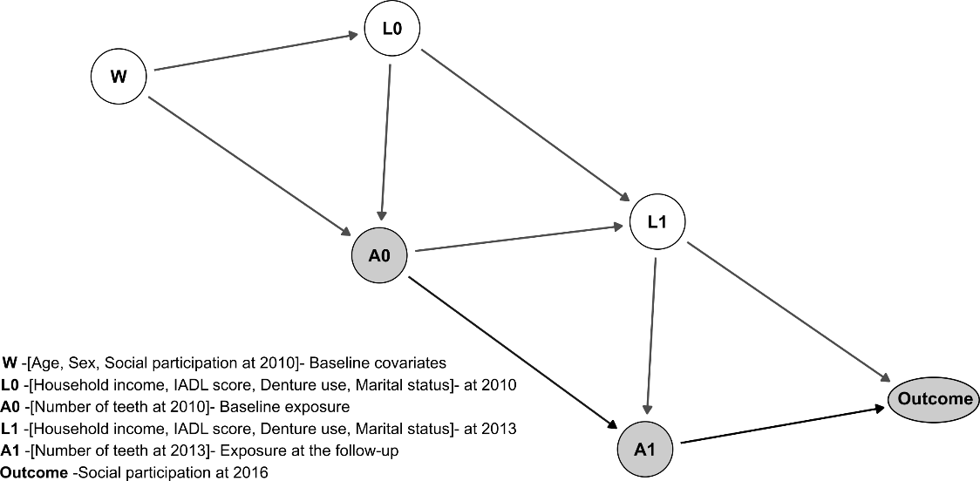

The directed acyclic graph (Figure 2) depicts hypothesised temporal relationships between study variables. A descriptive analysis was performed to identify the characteristics of participants stratified by the outcome (social participation in 2016). The counterfactual prevalence of social participation was then estimated using doubly-robust targeted maximum likelihood estimation (TMLE) [@Schuler2016]. In TMLE, the probability of the exposure conditional on covariates (exposure model), and the conditional probability of outcome given exposure and covariates (outcome model) were estimated to obtain unbiased estimation of the counterfactual outcomes [@Laan2006; @Schuler2016]. If either the exposure model or the outcome model was consistently estimated, unbiased estimates could be obtained (hence doubly-robust) [@Laan2012]. To increase the likelihood of robust specification of exposure and outcome models, we used SuperLearner, an ensemble method that uses weighted combinations of multiple machine learning algorithms [@Laan2007; @Rose2019; @Schomaker2019]. Within the SuperLearner, generalized linear models, extreme gradient boosting models, and neural nets were used as candidate algorithms. [@Venables2002; @Chen2016].

In that manner, TMLE was used to estimate the prevalence of social participation under a variety of hypothetical longitudinal intervention policies related to number of teeth. Specifically, Specifically, the following hypothetical intervention policies were investigated:

1. “all participants having ≥20 teeth in 2010 and in 2013,”
2. “all participants having 10-19 teeth in 2010 and in 2013,”
3. “all participants having 1-10 teeth in 2010 and in 2013,”
4. “all participants being edentate in 2010 and in 2013,”
5. “participants deteriorate by one category in terms of number of teeth in 2010 and in 2013 (see Figure 3)”
6. “no intervention” (estimation with originally observed data in 2010 and in 2013).

Using the prevalence estimate for the no intervention scenario (observed data) as the reference, we calculated odds ratios (ORs) and their 95% confidence intervals for the mean prevalence estimates of social participation related to the aforementioned different scenarios. As a result, the following contrasts could be investigated:

1. “no intervention” vs “having ≥20 teeth at 2010 and 2013”,
2. “no intervention” vs “having 1-9 teeth at 2010 and 2013”,
3. “no intervention” vs “having 10-19 teeth at 2010 and 2013”,
4. “no intervention” vs “deteriorate by one number of teeth category at 2010 and 2013”,
5. “no intervention” vs “being edentulous at 2010 and 2013”.

In addition, a secondary analysis was performed to estimate the effect of denture use on social participation among people with different numbers of teeth. To investigate the effect of denture use, two hypothetical interventions were set up: (1) all participants wearing dentures in 2010 and 2013, and (2) none of the participants wearing dentures in 2010 and 2013. To calculate ORs and 95% CIs, the scenario in which no one wears dentures was used as the reference. All estimates were appropriately controlled for time-variant and time-invariant covariates.

For imputation of missing data in covariates, we used random forest multivariate imputation by chained equations (MICE). In imputing complex epidemiologic data, random forest MICE has been shown to produce less biased parameter estimates and better confidence interval convergence compared to parametric MICE [@Shah2014]. We performed our analyses using five imputed datasets and the results were pooled using Rubin’s rules. Random forest MICE was implemented using *mice* R package [@Buuren2011]. The distribution of missingness among covariates is reported in supplementary Figure xx.

The *lmtp* R package was used to compute TMLE estimates with SuperLearner for each hypothetical intervention [@lmtpR]. Main R functions used to generate our results are provided in appendix xx. All the other codes that used for data preparation and supplementary analyses can be found at <https://github.com/upulcooray/socialParticipation>. All the analyses were conducted in R studio using R version 4.0.5 for Windows x64.

### Results

Baseline characteristics of the sample stratified by the outcome variable are presented in the Table 1. In the 2016 follow-up, 11,762 people reported a frequency of at least once a month social participation. Baseline characteristics associated with social non-participation in 2016 were older age, lower income, lower IADL score, edentulous or low number of teeth, and lower frequency of social participation at the baseline.

Table1

|  |  |  |
| --- | --- | --- |
|  | Social Participation in 2016 | |
| Baseline characteristics1 | Yes (N=11762) | No (N=10689) |
| **Age (range 65yrs-99yrs)** |  |  |
| Mean (SD) | 71.8 (4.6) | 72.7 (5.3) |
| **Household income (million yen)** |  |  |
| Mean (SD) | 2.6 (1.6) | 2.4 (1.5) |
| (Missing)2 | 1319 | 1533 |
| **IADL score (range 0-13)** |  |  |
| Mean (SD) | 12.3 (1.2) | 11.6 (1.6) |
| (Missing)2 | 799 | 937 |
| **Sex** |  |  |
| Male | 4868 (47.7%) | 5331 (52.3%) |
| Female | 6894 (56.3%) | 5358 (43.7%) |
| **Number of teeth in 2010** |  |  |
| Edentate | 829 (40.1%) | 1237 (59.9%) |
| 1-9 teeth | 2360 (46.6%) | 2702 (53.4%) |
| 10-19 teeth | 3223 (52.5%) | 2915 (47.5%) |
| >= 20 teeth | 5350 (58.2%) | 3835 (41.8%) |
| **Denture status2010** |  |  |
| Do not wear dentures | 5345 (53.3%) | 4678 (46.7%) |
| Wear dentures | 5690 (52.1%) | 5226 (47.9%) |
| (Missing)2 | 727 (48.1%) | 785 (51.9%) |
| **Social participation in 2010** |  |  |
| Everyday | 891 (86.3%) | 141 (13.7%) |
| 2-3 times a week | 3287 (88.1%) | 446 (11.9%) |
| Once a week | 2710 (79.5%) | 700 (20.5%) |
| 1-2 times a month | 2425 (63.1%) | 1420 (36.9%) |
| Few times a year | 1127 (28.2%) | 2867 (71.8%) |
| Never | 735 (16.3%) | 3778 (83.7%) |
| (Missing)2 | 587 (30.5%) | 1337 (69.5%) |
| **Marital status** |  |  |
| Widowed, divorced, or unmarried | 2736 (51.7%) | 2557 (48.3%) |
| Married | 8933 (52.7%) | 8021 (47.3%) |
| (Missing)2 | 93 (45.6%) | 111 (54.4%) |
| 1Mean (SD) for continuous variables; Frequency (%) for categorical variables | | |
| 2Missing values were imputed prior to main analyses | | |

Figure xx contrasts the mean prevalence estimates (TMLE estimates) of social participation related to various longitudinal hypothetical interventions to the prevalence estimate (TMLE estimate) of social participation in the data under the observed dental status. Having a relatively lower number of teeth negatively affected social participation after the six-year follow-up. After adjusting for age, sex, baseline social participation and time-varying confounders such as annual household income, IADL score, denture use, and marital status, consistent exposure to edentulousness would have lower the likelihood of social participation by 9% (OR= 0.91 & 95%CI= 0.84,0.99). Similarly, the odds of social participation was lower if everyone in the sample population deteriorate their dental status by one step in terms of number of teeth category (OR= 0.91 & 95%CI= 0.86,0.96). On the other hand, continuously being in 20 or more teeth category increased the social participation by 9% (OR= 1.09 & 95%CI= 1.07,1.11).

Results related to the effect of denture use on social participation for different number of teeth categories are shown in Figure xx.

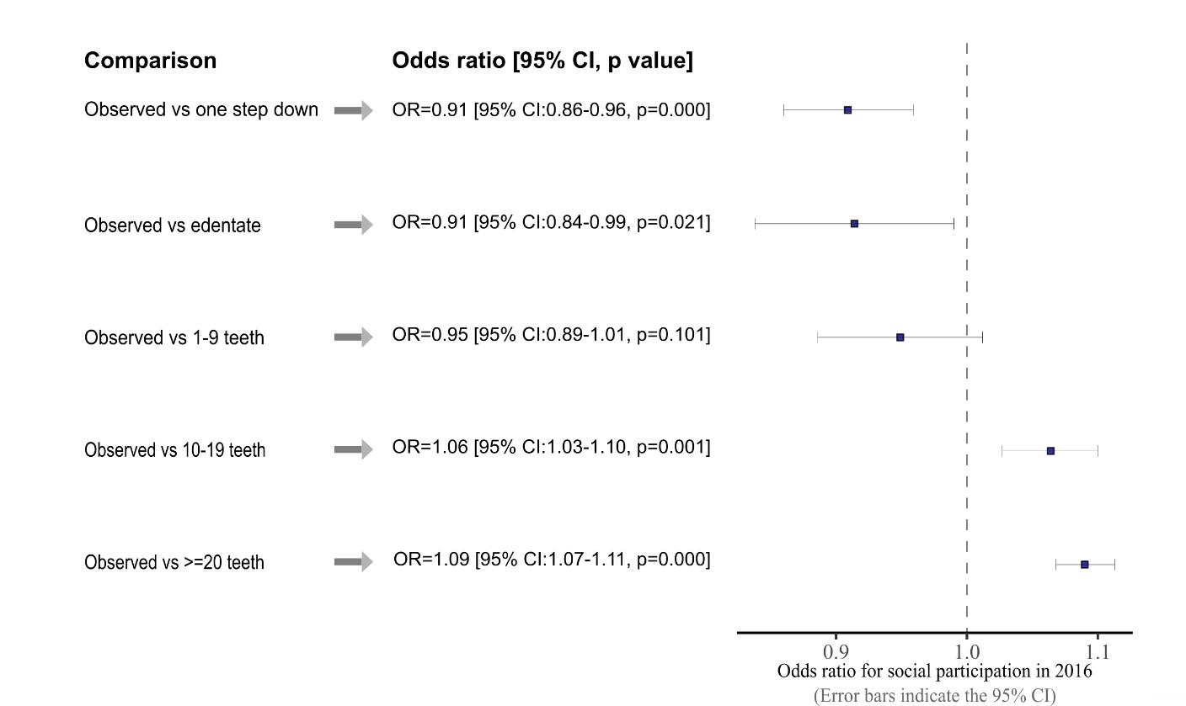

[Figure caption: Odds ratio for social participation under different hypothetical interventions (no intervention as the reference): OR,95% CI, p-value]

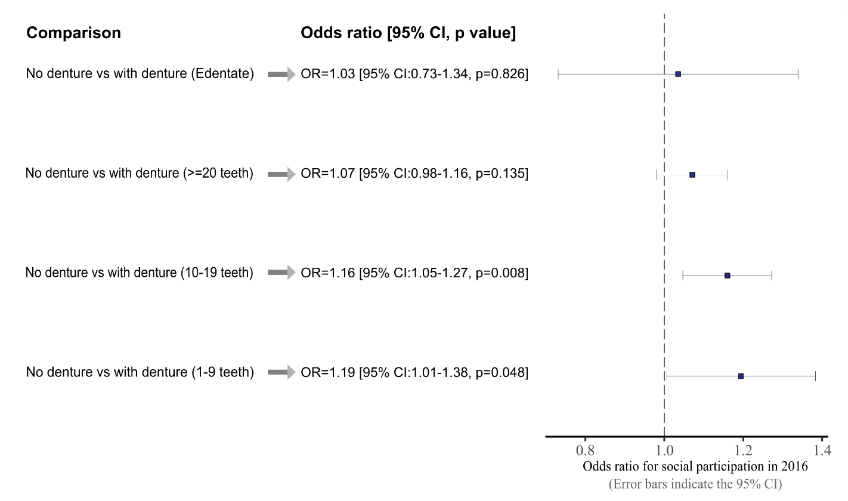

[Figure caption: Odds ratio for social participation for different number of teeth categories under hypothetical denture status levels (observed denture status as the reference): OR,95% CI, p-value]

The overall trend of the results indicated that denture wear had a positive effect on social participation across all number of teeth categories. However, the findings revealed that a significant beneficial effect of denture use on social participation could only be found in the 10-19 and 1-9 teeth categories (OR= 1.16 & 95%CI= 1.05,1.27; OR= 1.19 & 95%CI= 1.01,1.38, respectively). Social participation among the edentate group and those with more than 20 teeth did not appear to be affected by denture status.

### Discussion

Using an analytic approach that enabled assessing the effect of different levels of an exposure over time while adjusting for time-variant covariates, we estimated the effect of dental status on social participation. A doubly-robust estimator (TMLE) in combination with machine learning based ensemble (SuperLearner) was used to obtain the estimates. To the best of our knowledge, this is the first study to estimate the effect of number of remaining natural teeth on social participation.

Our analysis revealed that having a relatively higher number of teeth during the follow-up period improved the social participation among older adults in our study population. Being edentate and experiencing consistent tooth loss during the follow-up period reduced the social participation. Furthermore, our findings suggested that wearing dentures would improve social participation among older adults with 1-9 teeth or 10-19 teeth. Dentures did not appear to provide a significant benefit to edentate people in terms of improving social participation.

Our findings are consistent with prior findings related to the link between oral health and social participation [@]. However, previous studies were based on cross-sectional data and treated oral health as the dependent variable. Our analysis gave insight into how dental status would affect social participation using longitudinal data. Given the evidence that social participation improves the health and well-being of older adults, any mechanism that leads to increased levels of social participation should be promoted and encouraged [@]. In that context, our findings emphasise the importance of older adults retaining a higher number of teeth, not only for obvious benefits on oral functions such as mastication and speech, but also to have better social relationships and thus reap the benefits associated with social participation.

Our secondary analysis, which was intended to see if denture use could reduce the impact of dental status on social participation, identified that the benefit of dentures was limited to those who had 1-9 teeth or 10-19 teeth. These two groups are unique as they are in an unstable intermediary phase between minimal functional dentition (>=20 teeth) and edentate state. It is plausible that these two groups are more susceptible to the challenges posed by impaired oral functions as a result of tooth loss. Edentate people, on the other hand, transition into their edentate state over a long time period, so their baseline level of social participation may already be established, making them less likely to be affected by denture use. Overall, these findings suggest that preventing tooth loss in order to maintain a minimum functional dentition in older adults would be more effective than providing dental prosthesis in terms of improving social participation.

The use of a doubly-robust TMLE estimator to estimate the effects of multiple hypothetical interventions that are otherwise unmeasurable, can be considered the study's main strength. Furthermore, our estimates were based on longitudinal data while allowing time varying nature of the exposure and confounders. However, several limitations should be noted. Variables used in this study were based on self-reported measures, which are prone to measurement and classification errors. However, previous studies conducted in Japan have shown the validity of self-reported number of teeth [@Matsui2016; @Ueno2018]. Causal inference for time-varying exposure necessitates no unmeasured confounding assumption at each time point (conditional exchangeability assumption). Despite the fact that we adjusted estimates for multiple time-varying and time-invariant confounders, as well as baseline levels of social participation, the possibility of unmeasured confounding cannot be ruled out. In our analyses we used panel data with participant who participated in all three waves of the JAGES. Therefore, we had a large attrition of our sample population (n= 52053 at baseline to n= 22451 at 2016 follow-up). We examined the baseline characteristics associated with the attrition (supplementary table xx) and showed that it was associated lower number of teeth at the baseline. Low number of teeth affected negatively to social participation, thus, any selection bias caused due to attrition would have led to underestimation of the effects of tooth loss on social participation.

### Conclusions